**QSMART – QUARTER WAVE PLATE REPLACEMENT**

**PROCEDURE**

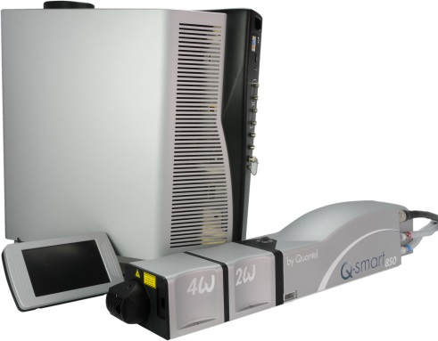

**Toolkit:**

* Allen keys set - metric
* Cover interlock holder RM100016A
* Energy meter

**System**: QSMART

|  |  |  |  |  |  |  |
| --- | --- | --- | --- | --- | --- | --- |
| |  |  | | --- | --- | | **SM010346** | **Q-SMART 1/4 WAVEPLATE ASSY** | |  |  |  |  |
|  |  |

**Purpose**: This document details how to change and adjust the quarter wave plate

|  |  |  |
| --- | --- | --- |
| Revision | date | modification |
| Initial issue | July 4, 2014 |  |
|  |  |  |
|  |  |  |
|  |  |  |

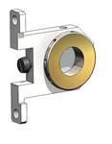

# DISASSEMBLING

* Turn the system off
* Disconnect cables and water hoses from the laser head side
* Remove the laser head cover.
* Remove the side plate (7 BHC 3x6)

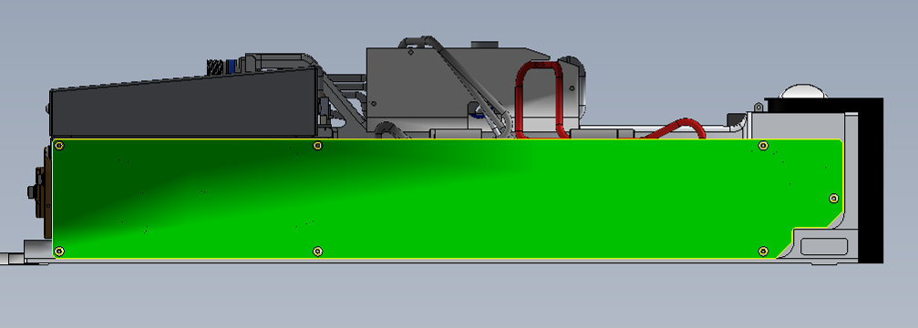

# HOLDOFF ¼ WAVE PLATE ADJUSTMENT

* Place
* Install the new holdoff ¼ wave plate

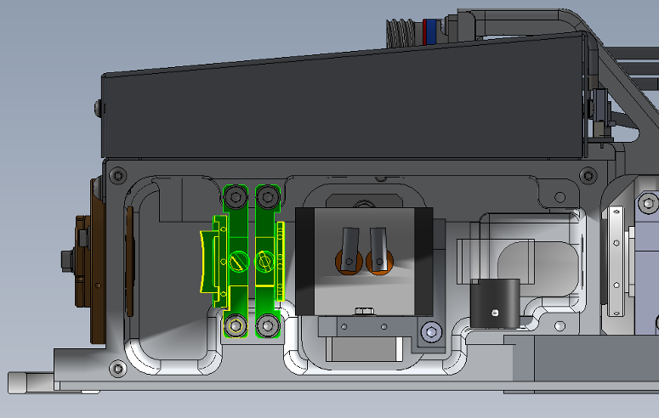

* Start the flashlamp
* Plug a photodiode to a scope in order to look the flaslamp fluorescence
* Rotate the ¼ wave plate to establish holdoff
* If there is still free running, adjust the Pockels cell

# ¼ WAVE PLATE ADJUSTMENT

* Put in place the quarter wave plate (be careful with direction).

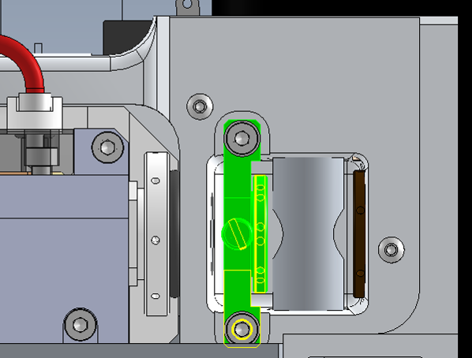

* Fasten it like shown on the assembly drawing with 2 CHC 4x8 + 2 ZU4
* Adjust the ¼ wave plate in order to get the maximum energy in Q-Switch mode with energy meter
* Fasten with nylon screw CLS 4x10

# CLOSING THE LASER CAVITY

Replace the side plate

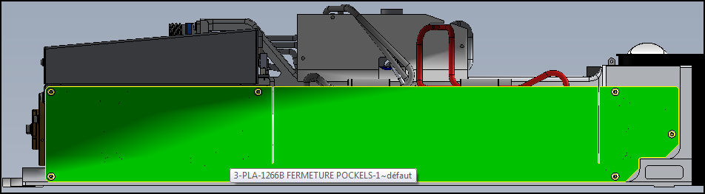

Wait until the plate is the same temperature as the laser head to tighten.

* Turn the system off
* Disconnect cables and water hoses on the laser head side
* Replace the laser head cover

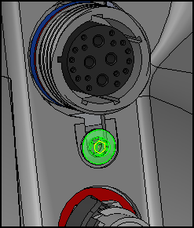

* Connect cables to the laser head
* Adjust lamp voltage to get 850mJ
* Check paper burns at 30cm, 1m et 2m to be confident

# SAVE PARAMETERS

* Save using Cmd = FPGMx2
* Close the Laser head and put warranty stickers   
  *Refer to "LH-Warranty Labels"*